# **Lesson Objectives**

* 1. Solve Quadratic Inequalities Graphically – when formula *is* or is *not* given.
  2. Solve Quadratic Inequalities Symbolically

# Solve Quadratic Inequalities **Graphically**

$f(x)=0$ means *y*-coordinate is **zero $f(x)=0$** is **ON** the *x*-axis

$f(x)>0$ means *y*-coordinate is **positive $f(x)>0$** is **ABOVE** the *x*-axis

$f(x)<0$ means *y*-coordinate is **negative $f(x)<0$** is **BELOW** the *x*-axis

## Solve Graphically When formula is **NOT** given

* **EXAMPLE:** Given the graph of $f(x)$, solve:

$f(x)>0$

2. $f(x)<0$. [3.4.23]

Before we can solve the inequality, we must first solve the **equation $f\left(x\right)=0$** .

The solutions are the *x*-intercepts.

The *x*-intercepts are: $(3,0)$ and $(5,0)$.

So, the solution to $f\left(x\right)=0$ based on the given graph is:

$x=3$ and $x=5$

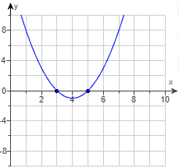

These are called **critical points** (CP) for the inequality. These two critical points now divide the domain (*x*) into three (3) distinct parts:

graph of a horizontal number line (x-axis) with the points (3,0) and (5,0) plotted.
Another way to say it:
The points x=3 and x=5 on a horizontal number line.

|  |  |  |  |
| --- | --- | --- | --- |
| **Left side** | | **Center** | **Right side** |
| **(written as inequality)** | $$x<3$$ | $$3<x<5$$ | $$x>5$$ |
| **(in interval notation)** | $$(-∞,3)$$ | $$(3,5)$$ | $$(5,∞)$$ |

NOTE: Make sure you can write these intervals in either inequality or interval notation!

(continued on next page)

(continued from previous page)

* + 1. Solve .

This means look **ABOVE** the *x*-axis.

There are **two pieces** of the graph that are **ABOVE** the *x*-axis – the “**tails**” of the graph.

* To the LEFTof $x=3$, which is $x<3$
* To the RIGHT of $x=5$,which is $x>5$

The correct solution for $f(x)>0$ is

$x<3 or x>5$,

or interval notation



* + 1. Solve .

This means look **BELOW** the *x*-axis.

There is **one piece** of the graph that is **BELOW** the *x*-axis – the “**bowl**” of the graph.

* In BETWEEN $x=3$ and $x=5$, which is the interval $3<x<5$

The correct solution for $f(x)>0$ is $3<x<5$,

or interval notation $(3,5)$.



* **EXAMPLE:** The graph of $f(x)=ax^{2}+bx+c$ is shown. Solve each inequality. [3.4.27]

$f\left(x\right)>0$

$f\left(x\right)<0$

This time there are **NO** *x*-intercepts. This problem takes a slightly different approach, so **be careful!**

1. $f\left(x\right)>0$ means **ABOVE** the *x*-axis. The graph of $f(x)$ is **never** above the *x*-axis!

This inequality has **NO SOLUTION** or $\{ \}$ or $∅$.

1. $f\left(x\right)<0$ means **BELOW** the *x*-axis. The graph of $f(x)$ is **always** below the *x*-axis!

The solution to the inequality is

**ALL REAL NUMBERS**,

or in interval notation, it is $\left(-∞,∞\right)$**.**

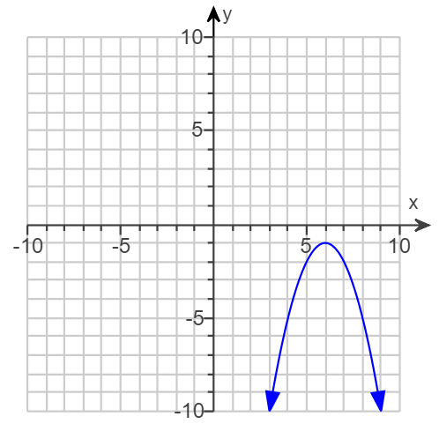

## Solve Graphically When formula **IS** given

* + - 1. Make sure you have **zero** on the right.
      2. Find the **solutions** – treat it as if it’s an equation.
      3. The solutionsare the **CRITICAL POINTS** (or *boundary points*).
      4. Graph critical points on a **number** **line** (*x*-axis).
      5. **Inspect** leading coefficient (***a***) to see if parabola opens UP or DOWN.
      6. **Sketch** parabola passing through number line.
      7. **Interpret** inequality symbol as either ABOVE or BELOW *x*-axis.
      8. **Write** solution in either inequality or interval notation.
* **EXAMPLE:** Solve the inequality. $x^{2}+4x-12≥0$ [3.4.39]

(Type your answer in interval notation. Simplify your answer. Use integers or fractions for any numbers in the expression.)

1. **Zero?** YES $x^{2}+4x-12=0$
2. **Solutions** Factor $\left(x+6\right)\left(x-2\right)=0$

Zero Product Property $x+6=0$ $x-2=0$

Solve each equation

$x=-6$ $x=2$

1. **Critical Points $x=-6$**  and $x=2$ (also called ***boundary*** *points*)
2. **Number Line** This is a horizontal number line numbered from -10 to 10, scaled by 1. There are points at  x=-6 and x=2 to indicate the critical points (CP) already identified earlier in the problem.
3. **Inspect your “*a*” $a=1$** , so parabola opens **UP**
4. **Sketch.** Sketch parabola opening UP, passing thru the *x*-intercepts $(-6,0)$ and $(2,0)$.

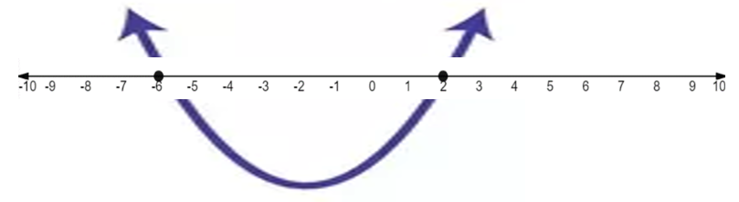

1. **Interpret.** Inequality is $≥0$

Use bracket or parentheses? **BRACKET**

Is it ABOVE or BELOW *x*-axis? **ABOVE** *x*-axis

One or two pieces? **TWO** piece(s), the“**tails**” (use “or” inequality)

1. **Write** solution Inequality: $x≤-6 or x≥2$

Interval Notation: $\left(-∞,6\right]∪[2,∞)$

* **EXAMPLE:** Solve the inequality. Write the solution in interval notation. [3.4.7]

$$x^{2}-x-56<0$$

An alternate way to solve by graphing is to use the graphing calculator.

This is how you’ll get the *x*-intercepts, or the **critical points** (or *boundary points*).

1. Get **zero** on the right, if needed.
2. Press **Y =** button on calculator.
3. Put **LEFT** side into **Y1,**

and put **ZERO** into **Y2**.

This is a screenshot from Texas Instruments TI-84 Plus CE graphing calculator with Y1=x^2-x-56 and Y2-0.

1. **Graph** it (press **ZOOM**, **6**).

This is a screenshot from Texas Instruments TI-84 Plus CE graphing calculator with Y1=x^2-x-56 and Y2-0.
It is the GRAPH with a standard viewing window, ZOOM 6.

* You do NOT need the vertex to solve an inequality.
* Make sure you can see the *x*-intercepts on the screen.
* You may need to Zoom Out. Press ZOOM, 3, ENTER – if needed.

1. To find the *x*-intercepts:
   1. Press **2ND**, **TRACE**, **5**: intersect, **↓** (down arrow) to switch to graph Y2.

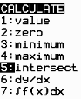

1. Move cursor to the LEFT *x*-intercept and press **ENTER three** (3) times.

Repeat process to get the RIGHT *x*-intercept.

This is a screenshot from Texas Instruments TI-84 Plus CE graphing calculator with Y1=x^2-x-56 and Y2-0.
This is showing the LEFT x-intercept after pressing 2nd, TRACE, 5 (intersect), then moving cursor to the LEFT intersection point and pressing ENTER 3 times.
It is the point x=-7 and y=0 or more simply (-7,0). This is a screenshot from Texas Instruments TI-84 Plus CE graphing calculator with Y1=x^2-x-56 and Y2-0.
This is showing the RIGHT x-intercept after pressing 2nd, TRACE, 5 (intersect), then moving cursor to the RIGHT intersection point and pressing ENTER 3 times.
It is the point x=8 and y=0 or more simply (8,0).

The *x*-intercepts are the **critical points**, which are $x=-7$ and $x=8$

1. **Inspect your “*a*”**. The value of $a=1$, which means opens **UP**.
2. **Sketch**.

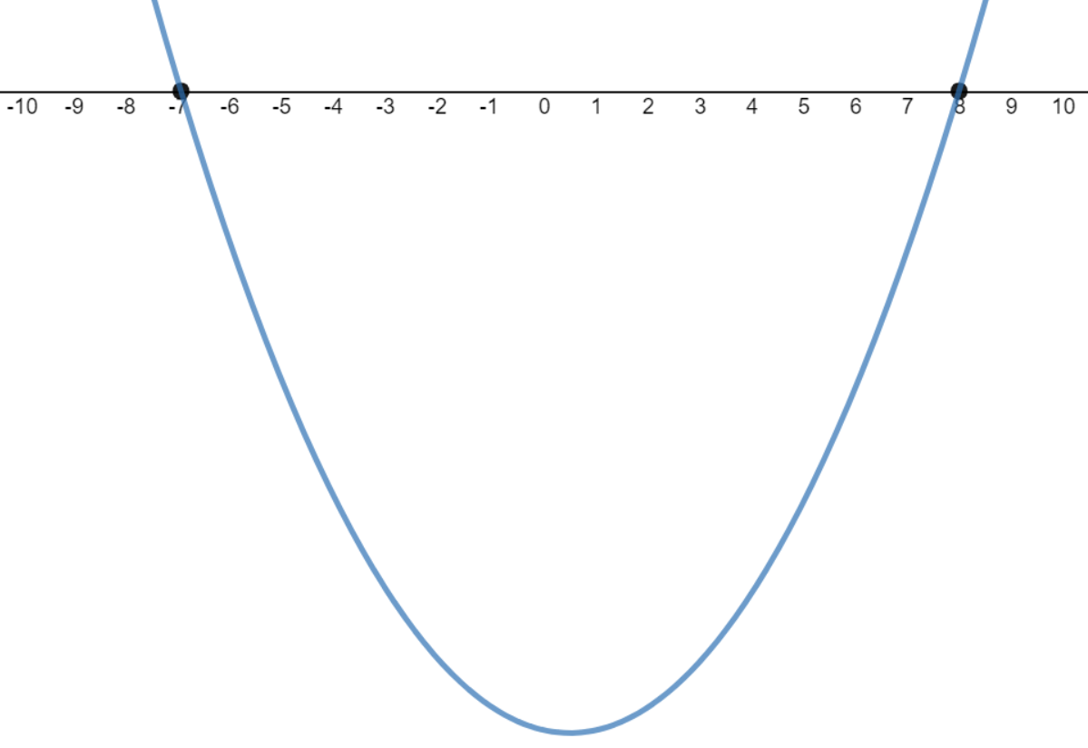

1. **Interpret**. Inequality is $<0$

Bracket or parentheses? **Parentheses**

Above or Below *x*-axis? **Below** *x*-axis

One or Two pieces? **One** piece(s), the“**bowl**” (use “in-between” inequality)

1. **Write** solution

Inequality: $-7<x<8$

Interval Notation: $(-7,8)$

# Solve Quadratic Inequalities **Symbolically** (by hand) using **TEST POINTS**

(The first 4 steps are identical to the graphical method at the top of page 3.)

1. Make sure you have **zero** on the right.
2. Find the **solutions** – treat it as if it’s an equation.
3. The solutions are the **CRITICAL POINTS** (or *boundary points*).
4. Graph critical points on a **number line** (*x*-axis).
5. Identify the **intervals** the critical points (or *boundary points*) create.
6. Use a **test point** (TP) from within each interval to test into the inequality.
7. The interval(s) that are **TRUE** are the **solutions**.

* **EXAMPLE:** Solve the inequality. $x^{2}-8x+15>0$ [3.4-10]

1. **Zero?** YES $x^{2}-8x+15=0$
2. **Solutions** Factor: $\left(x-3\right)\left(x-5\right)=0$

Zero Product Property: $x-3=0$ or $x-5=0$

Solve each equation: $x=3$ or $x=5$

1. **Critical Points (CP) $x=3 or x=5$**  (also called *boundary points*)
2. **Number Line**

This is a horizontal number line numbered from 0 to 7, scaled by 1. There are points at  x=3 and x=5 to indicate the critical points (CP) already identified earlier in the problem.

1. **Intervals**

(Inequality) $x<3$ $3<x<5$ $x>5$

(Interval Notation) $\left(-∞,3\right)$ $\left(3,5\right)$ $\left(5,∞\right)$

NOTE: Your **SOLUTION** will be one or more of these intervals.

(continued on next page)

(continued from previous page)

1. **Test Points (TP)**

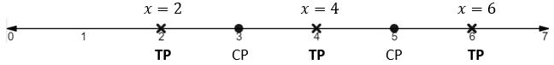

Using $x^{2}-8x+15>0$

Faster/easier if you use FACTORED form: $\left(x-3\right)\left(x-5\right)>0$

|  |  |  |
| --- | --- | --- |
| **Test $x=2$** | **Test $x=4$** | **Test $x=6$** |
| $$\left(2-3\right)\left(2-5\right)>0$$ | $$\left(4-3\right)\left(4-5\right)>0$$ | $$\left(6-3\right)\left(6-5\right)>0$$ |
| $$-1∙-3>0$$ | $$1∙-1>0$$ | $$3∙1>0$$ |
| $$3>0$$ | $$1>0$$ | $$3>0$$ |
| **TRUE** | **FALSE** | **TRUE** |
| All points are TRUE on the interval $x<3$ | All points are FALSE on the interval $3<x<5$ | All points are TRUE on the interval $x>5$ |

1. **TRUE** interval(s) **Solution** to the inequality $x^{2}-8x+15>0$ is:

(Inequality) $x<3 or x>5$

(Interval Notation) $\left(-∞,3\right)∪\left(5,∞\right)$

Sources Used:

1. MyLab Math for *College Algebra with Modeling and Visualization*, 6th Edition, Rockswold, Pearson Education Inc.
2. Number Line Inequalities (modified) from Desmos, <https://www.desmos.com/calculator/evxn1e1njv>, © 2019, Desmos, Inc.
3. Wabbitemu calculator emulator version 1.9.5.21 by Revolution Software, BootFree ©2006-2014 Ben Moody, Rom8x ©2005-2014 Andree Chea. Website <https://archive.codeplex.com/?p=wabbit>